Recital programs Laure de Marcellus and Alberto Urroz

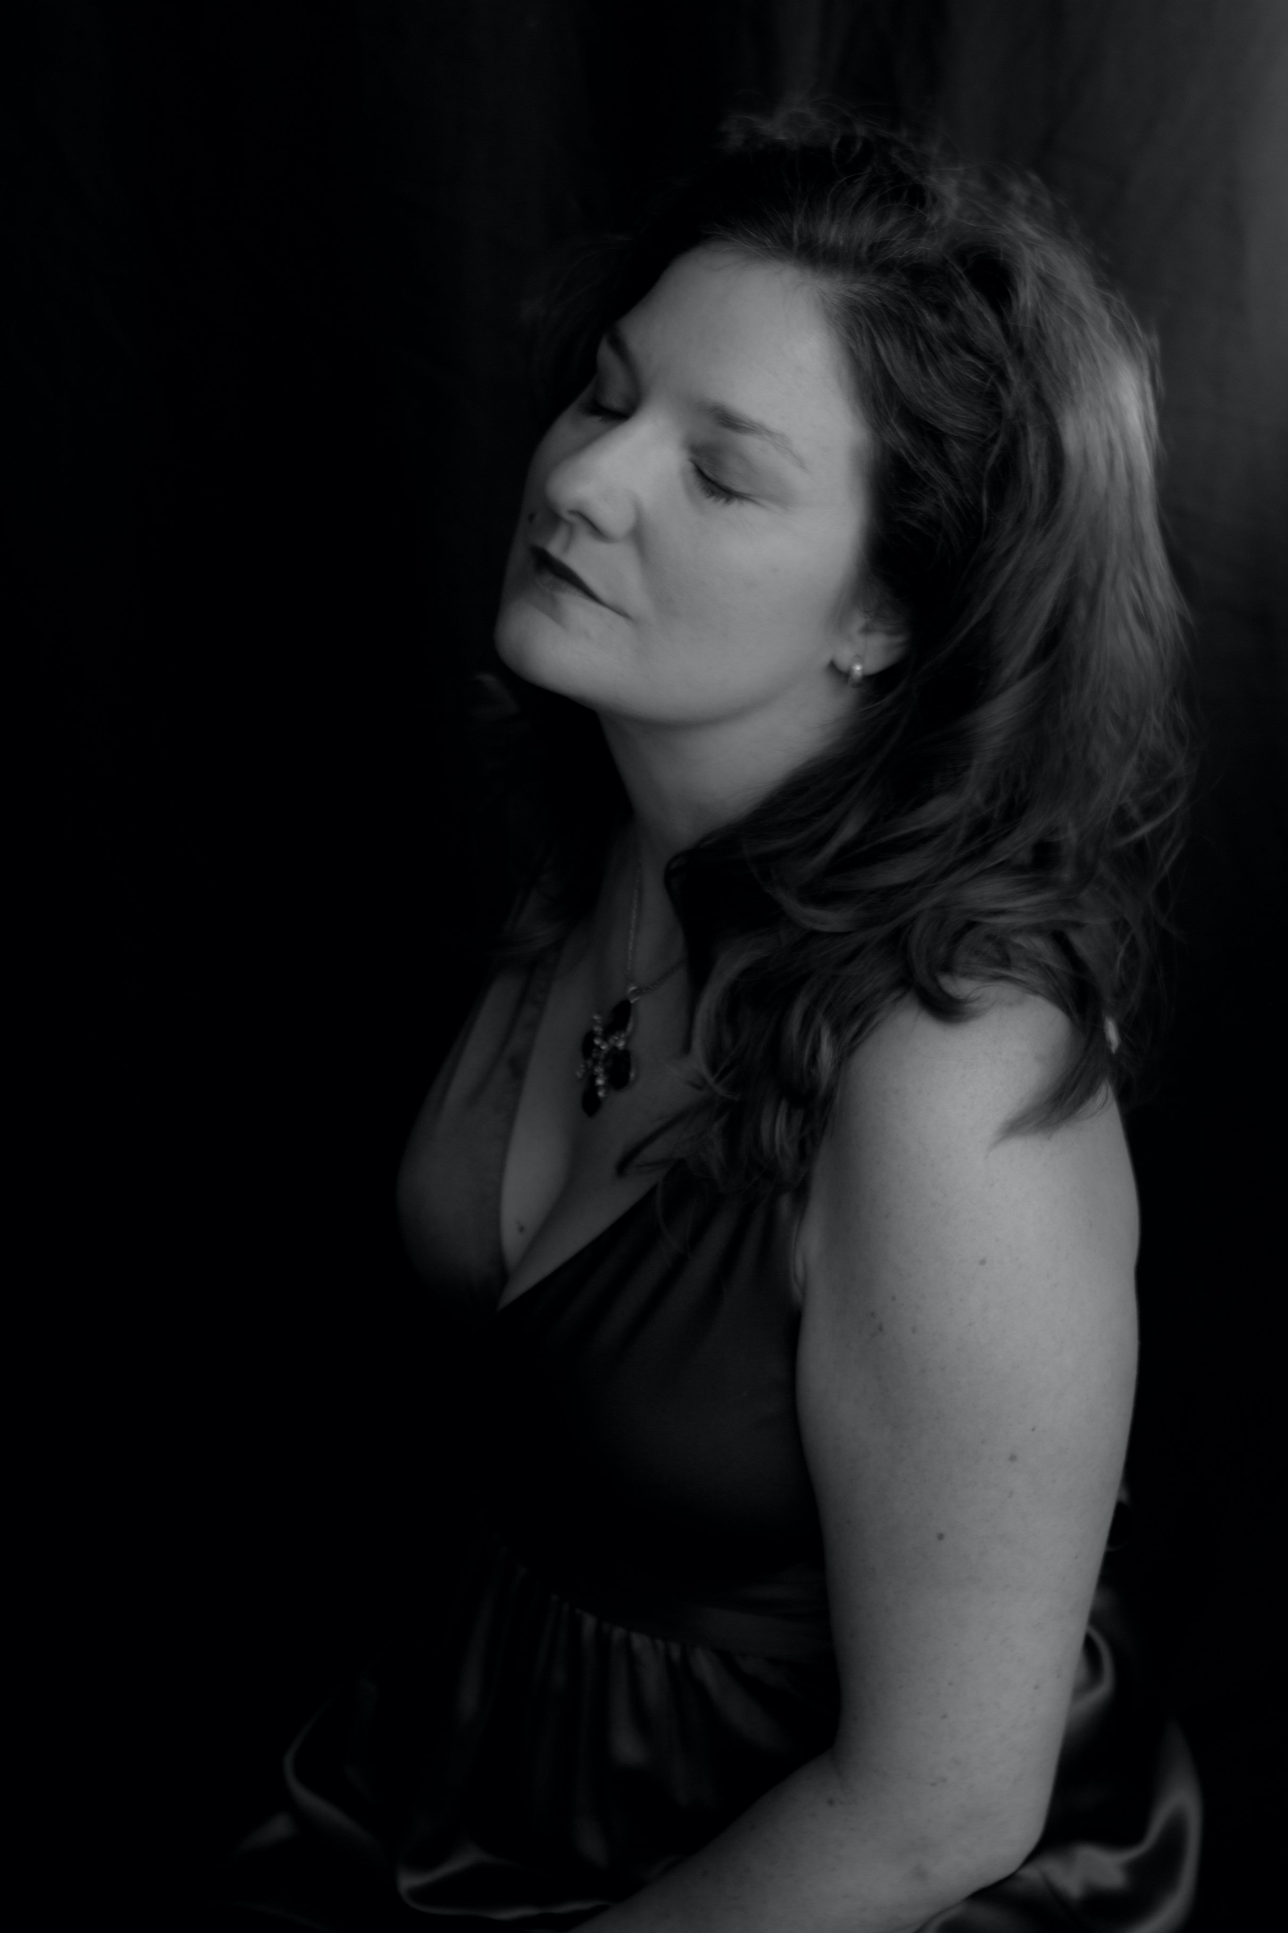

Heaven's Light
This program of Christmas songs is thought as a walk together with Mary as she goes through the different stages of her becoming and being the Mother of Christ, from the Annunciation to the difficult journey on a donkey's back, through her marveling at her power to nurse the Creator, with detours through lullabies and Nativity scenes brimming with life and joy.

Love and life of women

This program opens with music from the Love and Life of a Woman cycle which beautifully illustrates the love story of a woman for her husband, ranging from the ecstasy of the first encounter through the joys of motherhood all the way to the deep pain and resignation to his death. Composed in 1840, the year of the marriage between Robert and Clara, this cycle of songs is one of the composer's great offerings to his beloved. But this exalted love was also a source of inspiration for Clara Schumann, who herself dedicated several songs to her husband. The program continues by exploring the songs of their protégé, Johannes Brahms and of Clara's great friend, the singer Pauline Viardot, making a detour through contemporary music in the same line of exhilaration about love by the composer Teresa Catalan.

